Broadcast Emails
Before You Start
Throughout the program, Managers can see a Broadcast button on various search screens. Click the Broadcast button to create an email to send to members.
- Member Search screen – Send to the members displayed in search results
- Enrollment: Approved – Send to all approved members
- Events – Send to members listed in the registration search results
- Participation Search screen – Send to members listed in the search results
- Units – Send to members listed in a Club or Group
- Custom Reports – Send to all members listed on the selected report

Steps  - Enter the title of the message in the Title field. This is used to identify the message within the program.  - Enter the Subject of the email message. This will be the subject line that recipients see when they receive the message.  - Indicate if the message should be sent to Families (email address associated with the family profiles) or Members (email address associated with member profiles). If the Member record does not have an email address entered, the message will be sent to the email address on the Family Profile.  - You may select additional Configuration Options for the message. These include:  - Send to All Families (NOTE: This option does not work in connection with Families selected above. It must be used with Members selected.)  - Send to Emergency Contacts  - Sent to Unsubscribed  - Use My Email as Reply-To  - Sent Text Message Notification  - Click Create | Screenshots  (Screen appearance may vary per state)  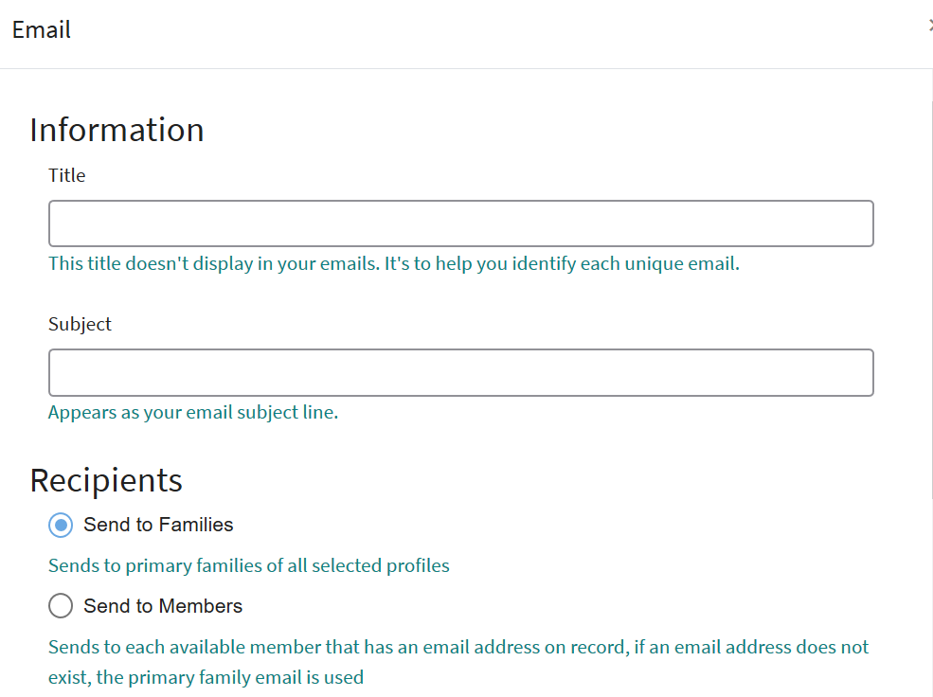  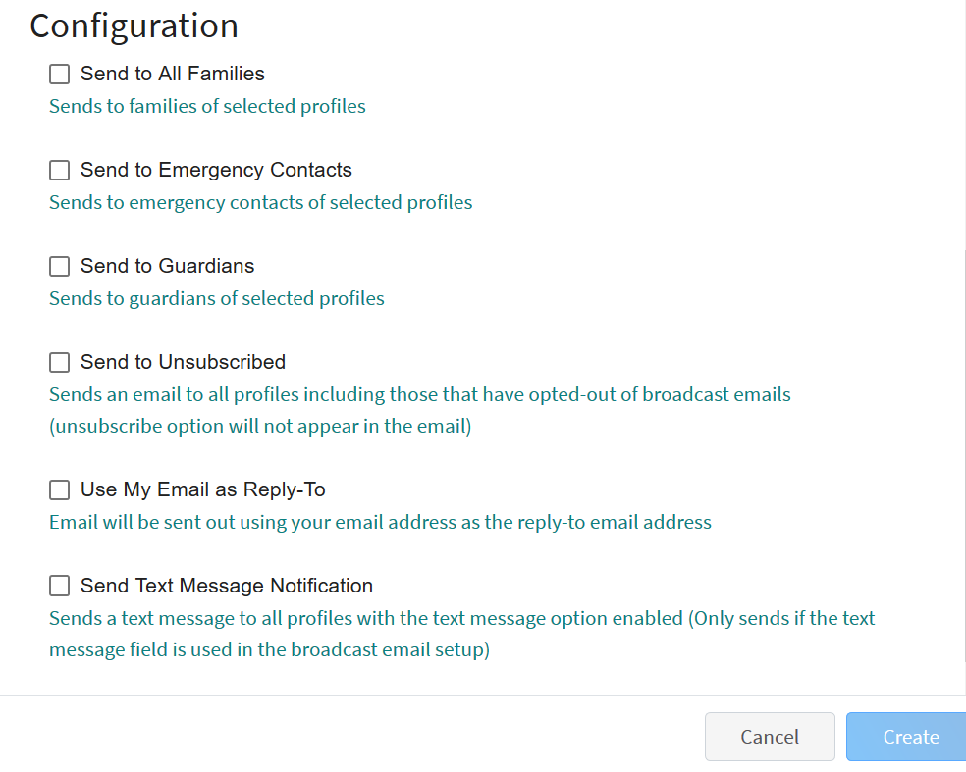

- The Recipient and Sender information will automatically fill in the To and From Fields.  - Click Edit next to Details to make corrections to the Title or Subject of the message.  - Click Edit next to Options to make changes to the configuration options selected. | 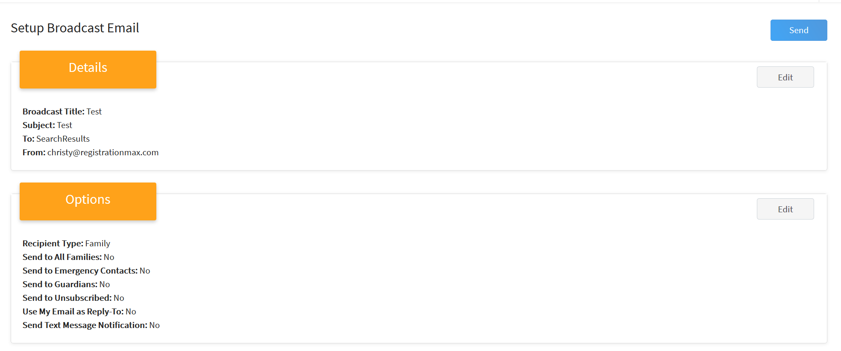
- Click Edit next to Content to enter the body text of the message.  - You may add an Email Variable (aka Form Field) to your message. Click the Email Variable name in the location you want to add the field. Remember to add appropriate spaces and punctuation around the field.  - Use the formatting bar to format the text of your message, add images, and create clickable links to websites.  - When finished composing your message, click the Save button. | 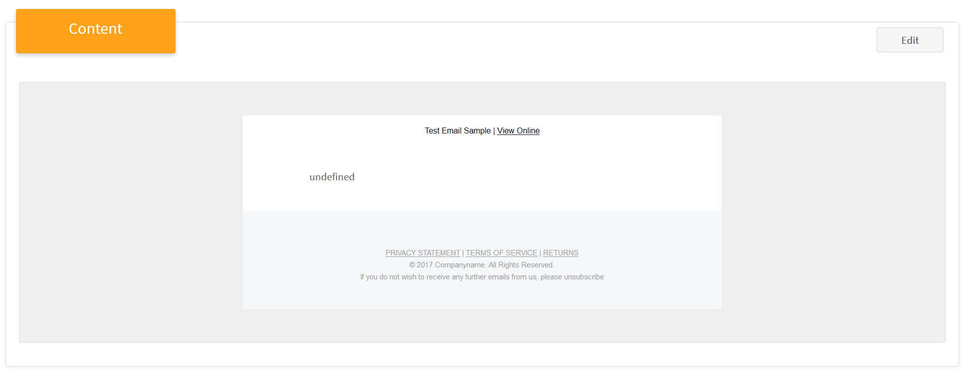  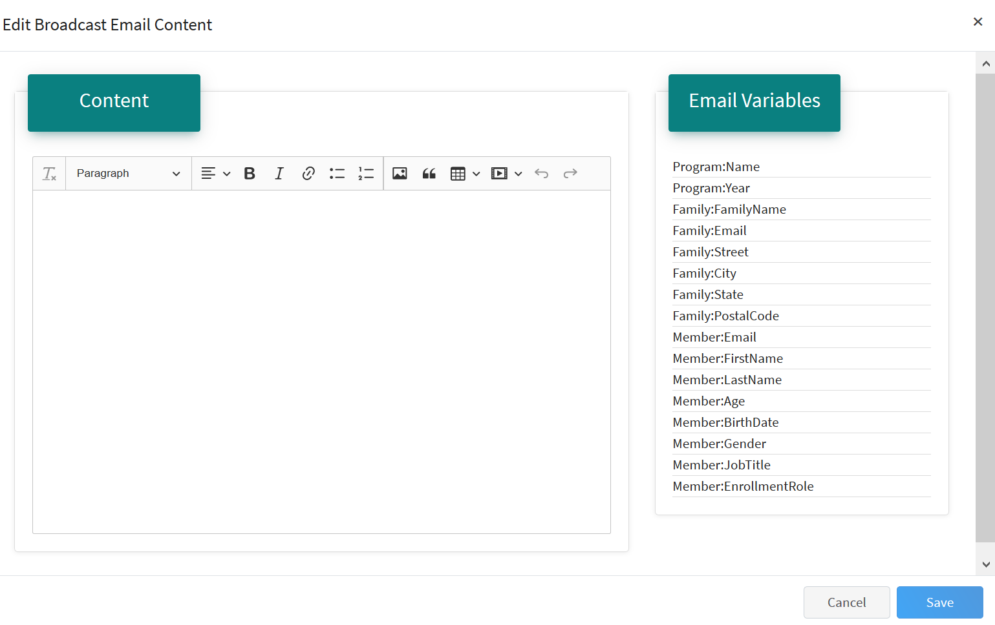
- Attachments can be added to Broadcast emails. Click the Upload button and select the file from your computer that you want to attach to the message.  Attachments to Broadcast emails must be one of the following file types: PDF (max size 40 MB), JPEG, JPG, and PNG. | 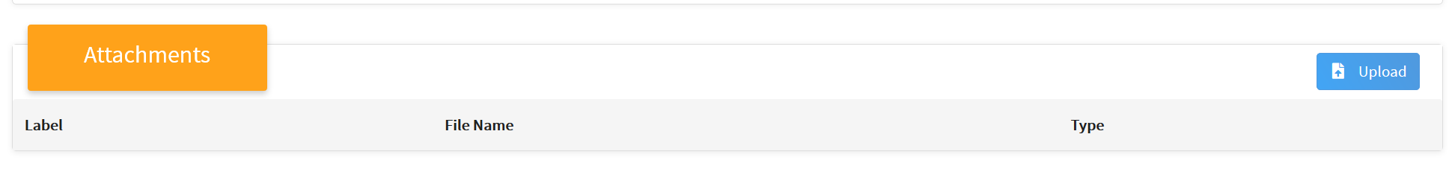
- Review the Recipients list. These are the Members/Families that will be sent the message, based on your selections. | 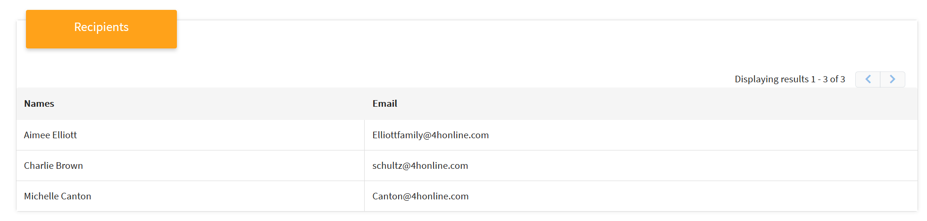

- When the message configuration, message text, attachments (if applicable), and recipients are correct, you may send a Preview of the message to yourself by clicking “Send to Self”.  - You may send a copy of the message to other managers of the same level as the sender, click Send to Hierarchy Managers.  - Once you have sent preview to yourself and to hierarchy managers as needed, Click the blue Send button located at the top of the page to send the message to the recipients. | 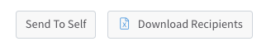  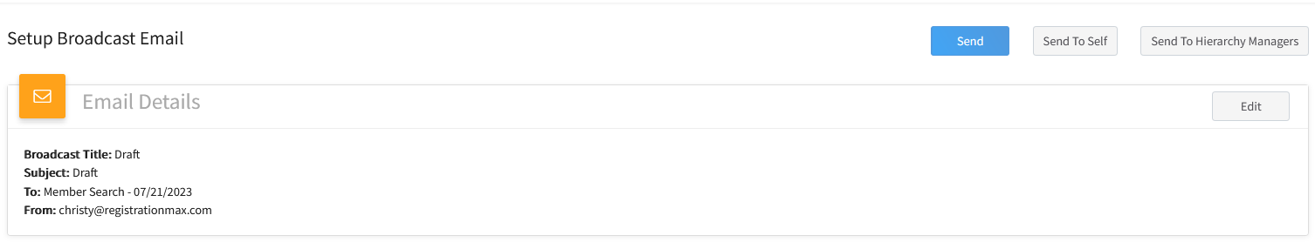
- After you have sent a broadcast email, when you click on it on the Broadcasts list, you will see the list of delivered and failed addresses on screen. | 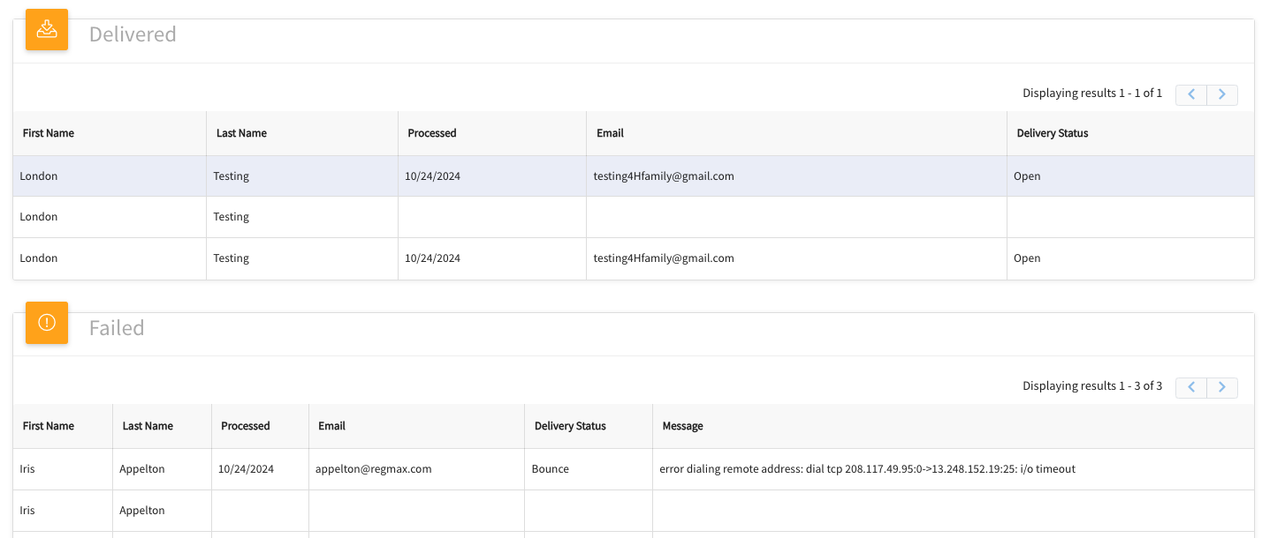
- For messages with a long list of recipients, it may be more useful to use the Download Recipients button (above the Email Details section) to download an Excel version of the recipients, with Delivered emails on one worksheet, and Failed on a separate worksheet. You can sort them in that spreadsheet in any way that is useful to you. | 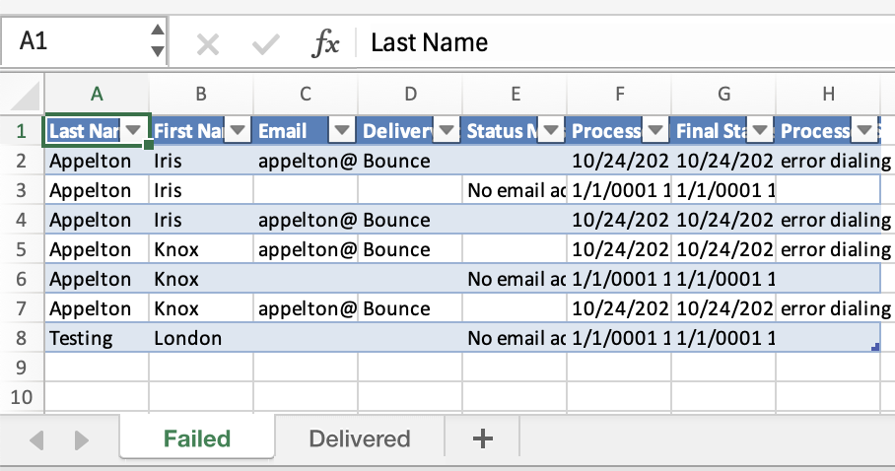
Tips
If you have created a draft broadcast email to send at a later date and have used a Search to gather the recipients, you will need do a new search to gather the list of recipients again before sending. This is to ensure the message is sent to the correct recipeints as you may have completed other searches between the time of drafting the message and sending it.

The configuration option for sending the email to Guardians is not functional.

